**HandsMen Threads: Elevating the Art of Sophistication in Men's Fashion**

**ABSTRACT**

This project describes the creation of a customized Salesforce CRM system for *HandsMen Threads*, a men’s fashion and tailoring brand. The goal was to make daily business tasks easier, improve customer communication, and keep information accurate across all departments.

To achieve this, a clear and organized data structure was built, including custom objects for Customers, Orders, Products, Inventory, and Campaigns. Automated processes were added using Flows, Email Alerts, and Apex to handle order updates, loyalty messages, and low-stock warnings without manual work.

Validation rules and role-based security were set up to protect data and ensure each team—Sales, Inventory, and Marketing—could access only what they need. A scheduled Apex job was also created to update stock levels automatically.

Overall, this CRM solution helps HandsMen Threads provide better service, work more efficiently, and prepare for future growth using the Salesforce Platform.

**OBJECTIVE**

The main objective of this project is to design and implement a customized Salesforce CRM system for *HandsMen Threads* to improve daily business operations, keep information accurate, and strengthen customer satisfaction.

By creating a centralized platform that manages customers, orders, products, inventory, and marketing activities, the project aims to:

* **Automate important tasks** such as sending order updates, loyalty notifications, and low-stock alerts.
* **Keep information reliable and consistent** through validation rules and structured data entry.
* **Provide up-to-date visibility** into inventory levels and customer interactions.
* **Improve teamwork and coordination** through secure, role-based access for each department.
* **Deliver better customer experiences** with targeted communication and personalized loyalty programs.

**TECHNOLOGY DESCRIPTION**

**Salesforce:-**

Salesforce is a cloud-based Customer Relationship Management (CRM) platform that helps businesses manage customer data, automate processes, and improve service, marketing, and sales operations. It provides point-and-click tools as well as programmatic capabilities (like Apex and Flows) to build custom business solutions.

**Custom Objects:-**

Objects in Salesforce are like tables in a database. Custom Objects are created to store specific data.  
Example:

* **Customer__c** – Stores customer info
* **Product__c** – Stores product details
* **Order__c** – Stores orders

**Tabs:-**

Tabs are used to display object data in the Salesforce UI.

Example: A tab for Product__c allows users to easily view and manage products.

**Custom App:-**

An App in Salesforce is a collection of tabs grouped together for a specific business purpose.

**Profiles:-**

Profiles define what a user can see, do, and edit in Salesforce. It controls object permissions, field access, and more.

**Roles:-**

Roles control the data visibility in Salesforce’s role hierarchy. It’s used for sharing settings and reporting.

**Permission Sets:-**

Permission Sets grant additional permissions to users without changing their profile.

**Validation Rules:-**

Validation Rules ensure data entered meets business criteria.  
Example:

* Email must contain @gmail.com
* Stock cannot be negative

**Email Templates:-**

Predefined formats for sending emails to customers or users.  
Example:

* "Order Confirmation" template

**Email Alerts:-**

Email Alerts are actions in Flows or Workflow Rules that send emails using predefined templates.  
Example: When a loyalty level changes, an email is sent to the customer.

**Flows:-**

Flows automate business logic without code. They can create, update, or send notifications.  
Example:

* Flow triggers email alerts on new order

**Apex:-**

Apex is Salesforce's object-oriented programming language. It allows developers to write custom logic.

Example Tiggers:

* Update Total_Amount__c in orders
* Reduce inventory stock

**DETAILED EXECUTION OF PROJECT PHASES**

1. **Salesforce Credentioals Setup/Developer Org Setup**

* A Salesforce Developer Org was created using <https://developer.salesforce.com/signup>
* This account was verified,password set,and access was granted to the Salesforce page.

**Account Activation**

This will be seen in your personal email. Click on the verify account to activate your account.

Give a password and answer a security question and click on change password. Then you will redirect to your salesforce setup page.

1. **Data Management-Objects/Custom Object Creation**

Five custom object were created to store business-critical data:

* **HandsMen Customer**- Stores customer information like email, phone, loyalty status.
* **HandsMen Product** - Stores product catalog details like SKU, price, and stock.
* **HandsMen Order**- Stores order placed by customers, including quantity and status.
* **Inventory- Tracks stock quantity and warehouse location.**
* **Marketing Campaign**- Stores promotional campaigns and scheduling.

**HandsMen Customer**

**HandsMen Product**

**HandsMen Order**

**Inventory**

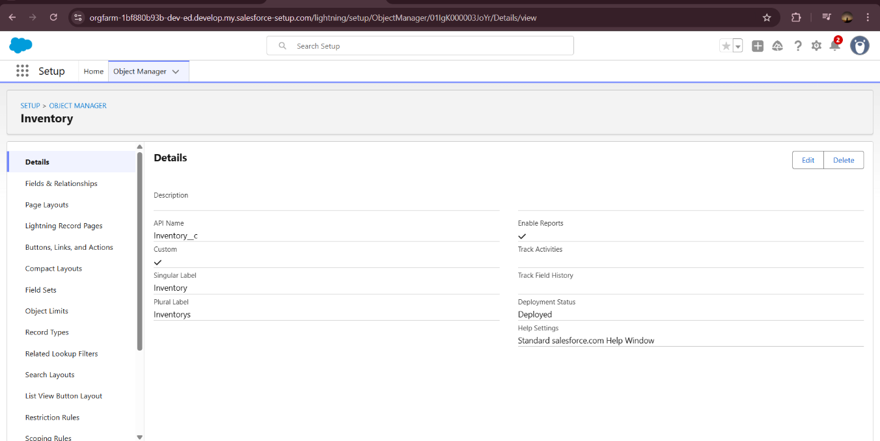

**Marketing Campaign**

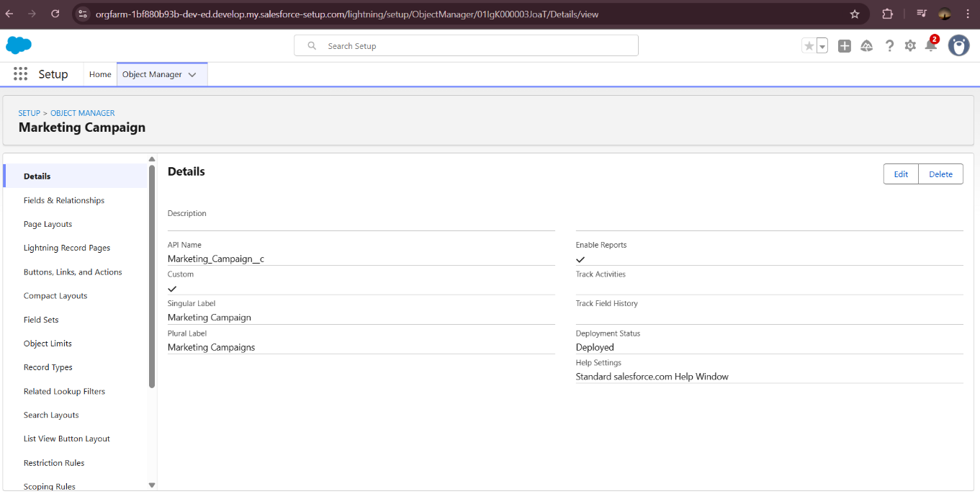

1. **Data Management-Tabs/Creating the Lightning App**

* Create custom Lightning App named Handsmen Threads
* Create Tabs for all the Objects

1. **Data Management- App Manager**

* Create custom Lightning App named Handsmen Threads

1. **Data Management-Fields**

* Create a Field-Email in HandsMen Customer object

* Create a Field-Phone in HandsMen Customer object

* Create a Field-Loyalty Status in HandsMen Customer object

* Create Lookup Relationship between Marketing Campaign and HandsSome Customer.

* Create Lookup Relationship between HandsMen Product and HandsMen Order

* Creating Lookup Relationship between HandsMen Order and HandsMen Customer

* Create Master-Detail Relationship between Inventory and Handsmen Product

* Create the Formula Field in HandsMen Customer object along with the FirstName and LastName field in the same object

* Create Remaining fields for the objects

1. **Data Configuration / Validation Rules**

To ensure accurate data entry and enforces business logic, the following validation rules were applied:

* Order Object: Prevents saving if Total_Amount__c<=0.

Error: “Please Enter Correct Amount.”

* Customer Object: Validate email contains @gmail.com

Error: “Please fill correct Gmai.”

* Create the validation rule for Postal Code field in HandsMen Order__c object

* Create a Validation rule for Inventory object.

* Create Validation rule for HandsMen Customer object.

1. **Data Security Profiles**

* Cloned the Standard User profile to a new profile named “Platform 1” and add access to necessary custom objects.

1. **Data Security-Roles**

* Create Sales Manager, Marketing Team and Inventory Manager Role

1. **Data Security-Users**

Users were created in Salesforce and assigned appropriate roles and profiles to reflect their responsibilities.

* Create user with the Name Niklaus Mikaelson and assigned to Sales role

* Create user with the Name Kol Mikaelson and assigned the Inventory role

* Create user with the Name Daniel Mikaelson

1. **Data Security- Permission Sets**

* Create a permission set with a label “Permission_Platform_1”

1. **Email Template and Flows**

Create three email templates:

* Order Confirmation- Sent when Order is placed
* Low Stock Alert- Sent when Inventory__c.Stock_Quantity__c < 5
* Loyalty Program Email- Sent when customer qualifies for loyalty rewards

Corresponding Email Alerts were create using these templates and linked to flows.

**Order Confirmation**

**Low Stock Alert**

**Loyalty Program Email**

1. **Order Confirmation Flow**

-Triggered when an order is updated to Confirmed.

- Send an Order Confirmation email to the related customer

1. **Stock Alert Flow**

-Triggered when Inventory stock drops below 5

-Sends Low Stock email to Inventory Manager

1. **Scheduled Flow: Loyalty Update**

-Runs daily at midnight

-Loops through customers and updates their Loyalty status based on total purchases.

1. **Automation Using Apex**
   * Order Total Trigger – auto calculates Total Amount based on quantity and unit price
   * Stock Deduction Trigger- Reduce stock when an order is placed
   * Loyalty Status Trigger – Updates Loyalty Status based on the Total Purchases

Create Apex Class name as “OrderTriggerHandler”.

Create Apex Trigger name as “OrderTrigger”, and select “HandsMen_Order__c” from the dropdown for Object.

1. **Batch Jobs**

Create Apex Class name as “InventoryBatchJob”.

**Schedule the Apex class**

**PROJECT EXPLANATIONS WITH REAL WORLD EXAMPLE\**

1. **Customer Registration**

* A customer, Raven Rhay Mikaelson, visits the store or website
* A record will be crated in the Salesforce
* Validation Rule: Ensures the email is valid (e.g., must contain @gmail.com).

1. **Product Setup**

* The admin adds products like Shirts, Jeans, etc., into the Product__c object.
* Each product has a price and other details.
* Inventory is also created to manage stock for these products.

1. **Order Placement**

* Raven Rhay Mikaelson decides to buy 600 shirts (each ₹500). An order is placed.
* In Salesforce: A new Order record is created.
* Apex Trigger: Automatically calculates Total Amount

1. **Inventory Update**

As soon the order is placed:

* The apex trigger on Inventory: Reduces shirt stock
* Validation Rule: Ensures stock never goes below 0

1. **Loyalty Program**

* Raven Rhay Mikaelson now has purchase of 300,000
* A trigger on Customer checks his total purchases.

Based on the value:

<500 = Bronze

500-1000 = Silver

1000 = Gold

* So, she becomes a Gold member

1. **Email Notification**

* When a new order is placed or loyalty status is updated
* Flow + Email Alert Triggered
* She got an email: “Your Order has been Confirmed!”

1. **Users and Roles**

Salesforce users like store staff are created:

* Niklaus Mikaelson and assigned to Sales role
* Kol Mikaelson and assigned the Inventory role
* Daniel Mikaelson and assigned the Marketing role

From this feature to the Batch Job the screenshots will be the same from the photo above.

**SCREENSHOTS**

**Fig: Custom App for Handsmen Threads**

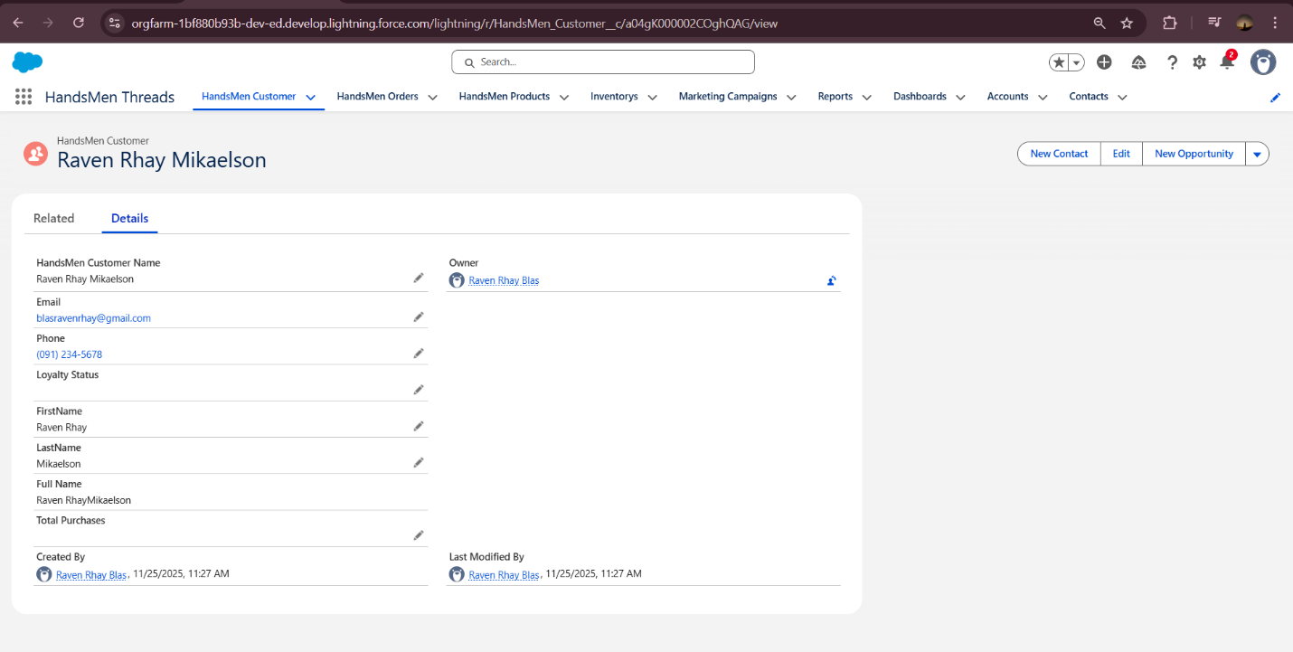

**Fig: Customer Creation in Handsmen Threads**

**Fig: Products in Handsmen Threads**

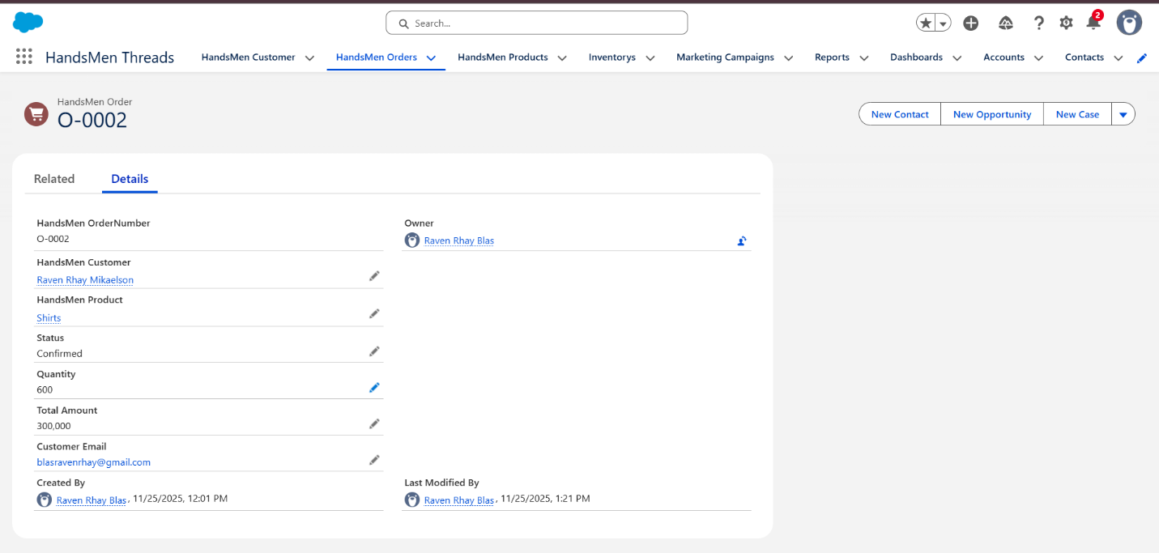

**Fig: Order Confirmation**

**Fig: Order Confirmation Email**

**Fig: Inventory**

**Fig: Low Stock Alert Email**

**Fig: Loyalty Program Email**

**Deployment, Documentation & Maintenance**

The system will be deployed using [state method, e.g., change sets, direct server upload, or Git], ensuring updates and new features are applied efficiently with minimal disruption, while backups are made before every deployment to prevent data loss. Maintenance will include regular monitoring of server performance, software updates, and routine backups to keep the system running smoothly. A troubleshooting guide will also be provided, with step-by-step instructions for resolving common issues such as login problems, data entry errors, or system crashes, along with detailed logs to help diagnose and fix problems quickly.

**CONCLUSION**

This project successfully developed a system that helps [state your purpose, e.g., manage the School-Based Feeding Program or analyze sales data] more efficiently by simplifying tasks, reducing errors, and providing useful insights for better decision-making. In the future, the system can be improved by adding a chatbot for instant user support, incorporating AI suggestions for smarter recommendations, creating a mobile version for easier access, and enhancing reports and dashboards for better data visualization. These improvements will make the system even more user-friendly, intelligent, and effective in achieving its purpose.

.